DIS-ME-Sassanian-Cameo-Carnelian

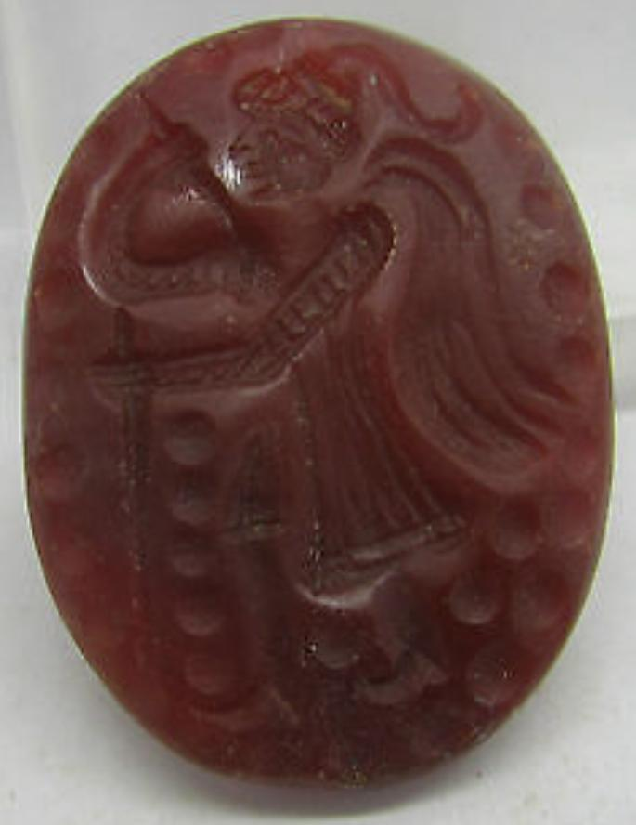

Sassanian carnelian cameo ca. 600 AD Item in fine condition.

EX Michael Davies, 2 Hanover Court, Didcot, Oxfordshire, ox11 8nu, United Kingdom